CARROT Website Copy

## // Site navigation bar //

Twitter Url <https://twitter.com/carrot_research>

Insta Url

Facebook Url <https://www.facebook.com/Carrot-Research-101029866085111>

Reddit URL https://www.reddit.com/user/Carrot-Research

Logo // Direct to home page //

* How to Buy (Drop down menu)
  + [How to set up Trust Wallet](https://docs.google.com/document/d/122d44rZDNIetOfJlLOSiBuUDPFkXhjIvVb4G2Q1U_hw/edit#heading=h.qzke624mfbs2)
  + [How to set up Metamask](https://docs.google.com/document/d/1rUyUvZJQBWaZl14Dc-wPLkPmaNZTjKEfO8ccSfwrUmQ/edit#heading=h.lqhc01nm3hnt)
  + [How to buy ETH](https://docs.google.com/document/d/1IWG3NsUVbhXaSHBiedklkGrx4B8WoqiUC9SjRt69EQg/edit#heading=h.4i6v96s7tt3g)
  + How to buy on UniSwap
* Whitepaper (Direct to new page containing whitepaper)
* Audit (Direct to new page containing audit)
* Work with us (seperate page with the following subheadings)
  + Tastemaker
  + Client/Brand onboarding
  + User referral scheme
  + Web-Tester
  + Telemarketing
  + Brand specialist
  + Data scientist
  + Behavioural analysts
  + Account Director
* Press (Direct to full press section with up to date articles)
* Social Communities (dropdown menu containing the following clickable links)
  + Twitter
  + Telegram
  + Instagram
  + Reddit
  + Discord

**CTA- “LAUNCH PRODUCT”** Far right of nav bar.

# 

# // Homepage /

Hero- // Carousel - 3 x Slides, Image background and text // find brand appropriate imagery

What if you could ask 1million people the same question

What if you could ask your exact target audience their opinion

What if you could do it in real time from anywhere

This is made possible with blockchain technology - (Can we have this a bit different entrance effect to make it stand out more.

// CTA 1 // Setting the scene

Knowing if a product is viable before launching is key to a company's success. Market research has historically been undertaken through small select groups of individuals to try and understand this. But how many opinions is enough to be an accurate representation of a market? And how do you know they are the correct ones?

// CTA 2 // Solution

Our answer is **MASS ACCURACY**. By delivering the wisdom of the crowd, we will be building the largest group of opinion providers ever seen. Utilizing web3 technology to create a seamless reward mechanism to encourage anyone to take part, we’ll both maximize the potential number of opinion givers AND empower you to create the exact audience you want the opinion of.

// CTA 3 //Next step

We are focused on three things .

1. Building the worlds largest opinion pool

2. Creating technology which **maximises** accuracy of opinion and **minimises** per opinion cost ( POC )

3. Making our platform as accessible as possible to anyone.

We’ll do this by creating a ***taste algorithm*** from our pool of **anonymised** data, giving clients instant access to an opinion derived from hundreds of thousands of views. All the while monetising opinion,

by creating a ***taste passport***, which gives back the ownership and monetisation of data to each individual.

## ICO and Presale (countdown timer to launch)

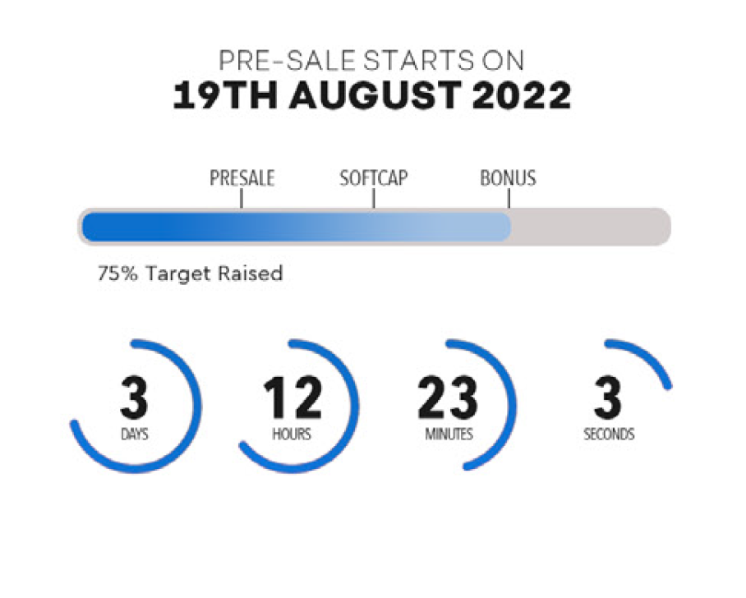

## Key Features

We need to find image icons that fit with each section inline with brand guidelines

### Client portal

* + As a client this will enable you to track any research projects you have in action, request realtime research from our taste algorithm and track any brand mentions in the community

### Tastemaker portal

* + As a tastemaker you will be able to keep track of your rewards, request for opinions, see brand offers and how accurate your opinion has been

### Research Builder

* + Our research builder enables you to create a market research project through a few simple steps. Simply define your target audience silos, product type, type of audience, and the specific questions you wish to ask and we’ll action it within 72 hours.

### Taste Algorithm

* + A continually evolving codebase, our taste algorithm is a machine learning tool which is trained by ( eventually ) millions of opinions. It enables us to deliver an instant snapshot opinion on products and services, with manual research groups available as a follow on. Using every facet of machine learning, from image recognition to natural language processing, it gives you the power of a million opinions and a thousand servers in the palm of your hand

### Taste Passport

* + By curating ***anonymised, permissioned opinion*** we provide marketers with a new data source - qualified, verified opinion. Unlike the last wave of internet giants, who shared none of their revenue with their users, we’ll pass the majority of income to you via your taste passport. Brands will buy access to opinion and interaction using our token via their client dashboard or via API.

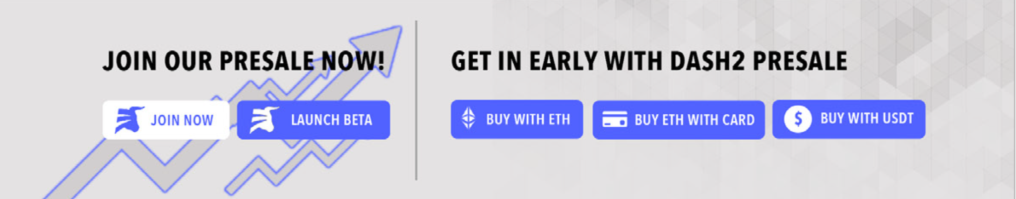

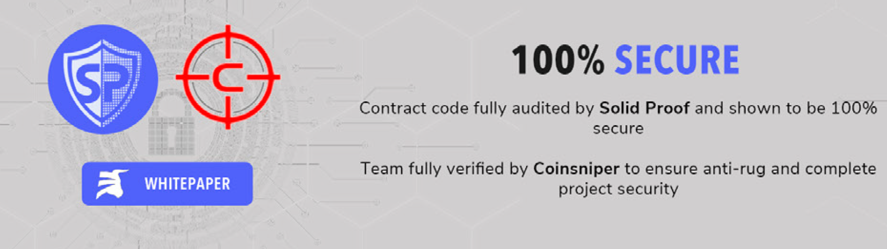

Add this section, lets look at different styles and layout, more fitting within the brand.

I think we need circle, carrot style CTAs.

EXPLAINER VIDEO

## TOKENOMICS ???

**1 BILLION TOKENS**

* PRIVATE SALE 10%
* PUBLIC SALE 45%
* DEVELOPMENT 30%
* PROFIT SHARE POOL 10%
  + The profit pool that will pay the tastemakers their incentives
* R&D 5%
  + Research and development by marketing and psychologist phds to assist in creating surveys to shape the machine learning algorith

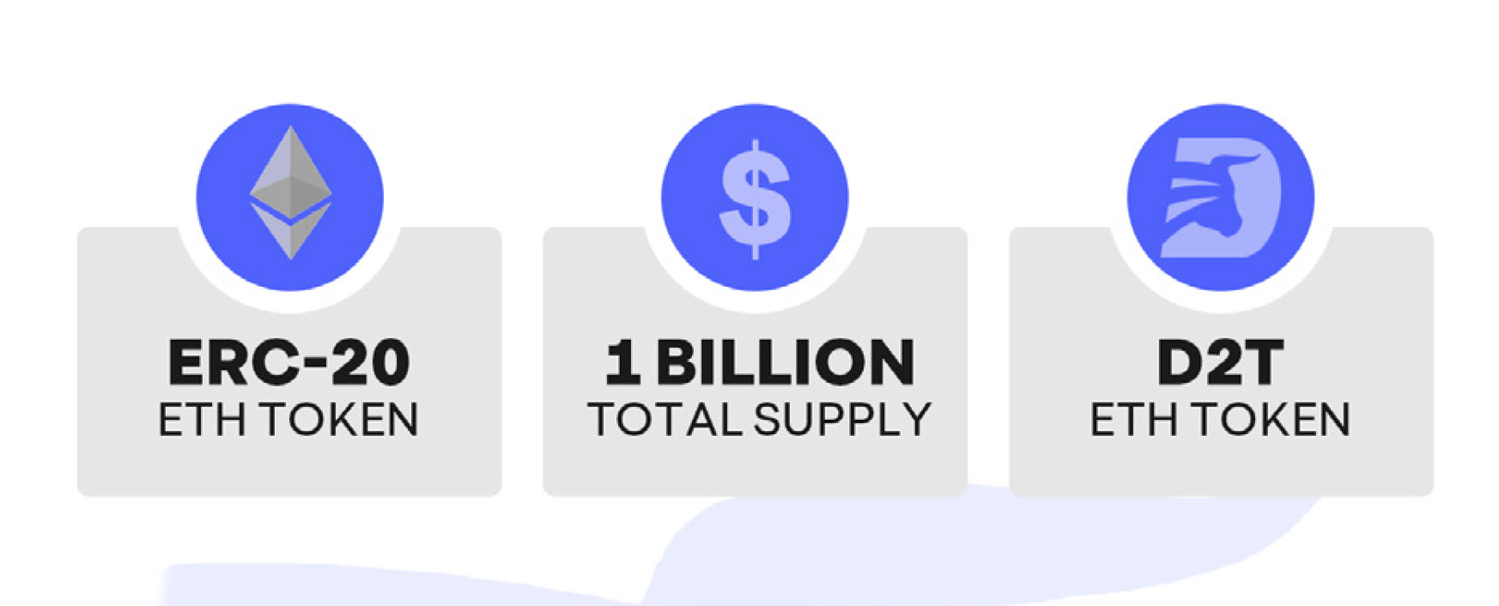

Change last one to Carrot logo and $CRT ETH TOKEN

## 

## 

# Become a Tastemaker

(Find brand appropriate imagery for each field)

HAVE THE FOLLOWING 5 SLIDES ON A MOVING CAROUSEL

Marketing Quote: “WE JUST BRING THE CARROT, NOT THE STICK”

## Earn a passive income

## Choose your own working hours

## Work from anywhere in the world

## Work on the go

## Become an ambassador to your favorite brands

If you want to become a tastemaker, please click the link below to join the waitlist.

// join waiting list link //

# Brand/Clients

If you are a brand or agency that wants to see the next generation of market research please complete the form below and one of our representatives will be in touch.

// Contact form //

# 

# Roadmap

### Phase 1

* Develop platform Prototype
* Presale of $CRT token
* Launch marketing campaign to drive engagement in the $CRT token to retail customers
* Token listing on CoinGecko and Coin MarketCap
* Secure Investor Financing
* Secure client brands/agencies trials for portal membership
* Build advisory board
* Develop Focus Block portal ready for Beta access

### Phase 2

* Launch Focus Block portal allowing users to register and create profiles
* Onboard first 1000 users
* Run dedicated ad campaigns to build user base
* Build customer database to use and test the Beta environment based on global top 1000 advertising and public relations agencies

### Phase 3

* Progressive web application
* Direct Advertising through portal
* Metaverse integration - live taste tests on Meta / Sandbox etc
* NFT distribution for qualifying consumer level
* CEX Listing

### Phase 4

* Machine learning algorithm that defines what “ Taste “ is . Will enable brands to build highly focused virtual research groups and generate insights without human interaction, at much lower cost.
* “Taste Passport '' - an ERC-1155 Non fungible token which will allow users to monetise their choices on the wider internet by providing permissioned access to their taste profile and allowing advertisers to target them. Will also allow brands to request real time feedback on any web accessible site content. Rewards will be in $FBLOCK tokens providing upward buy pressure.

## 

## Partners and Supporters

## 

## Our Team

Carrot will build a team of industry natives who speak the same language as our target client base. By hiring PR and marketing specialists we will be able to pivot from shared frustrations of existing solutions .

It is also key that we lead the market in technological applications. We are actively looking for data scientists with specialties in graph databases and artificial intelligence amongst other technical roles.

Advisory Board

We will also build out an advisory board to provide strategic and scientific insights for continued platform growth. We are targeting individuals who hold doctorate degrees in marketing , behavioural science, and also thought leadership in public relations and/or marketing across a breadth of demographics.

## Contacts us

**Address**

Block Media Ltd - 67 Fort Street, Artemis House, Grand Cayman, KY1-1111, Cayman Islands.

**Contact emails**

Buying assistance: buy@dash2.trade

General enquiries: admin@dash2.trade

Marketing: marketing@dash2.trade

Press: pr@dash2.trade

Please set up [admin@carrot-research.com](mailto:admin@carrot-research.com) only at this stage

**Footer content**

Disclaimer: Your investment may go down as well as up in value. Cryptocurrency is not regulated in the UK.

Please amend all policies to suit Carrot

[Privacy Policy](https://docs.google.com/document/d/17nJKkuEwK7fDDzoIQt1T9f_1C1i5rc2ohx4XYZS_JWI/edit)

[Cookie policy](https://docs.google.com/document/d/15ypkNBk3_tDwjqinmZGlpdvkiAFp7m-zRmwww1kQoio/edit)

[Terms](https://docs.google.com/document/d/15k0BW6Wp2AnjVw8t5qy0ubuHahpQs7DQ-pqnXlZFNI0/edit)

Social media icons:

Twitter:

Instagram:

Telegram:

Discord:

Reddit: